Exercises: Docker Compose
Exercises for the "Containers and Clouds" course @ SoftUni

*MariaDB Client and Server in a Network
MariaDB Server (a variant of MySQL) is one of the most popular open-source relational databases. You should use it documentation on Docker Hub to create two containers, which will work together:
- MariaDB database server container, initialized with database user and password.
- Another container, which will run the MariaDB command line client against the MariaDB server container, allowing you to execute SQL statements against your database instance.
Both containers will use the same Docker image. The image is available here: https://hub.docker.com/_/mariadb.
Note: In order for the containers to work together, they should be in the same network. See in the documentation how to create a network and connect both containers to it.
At the end, you should have two containers like this:
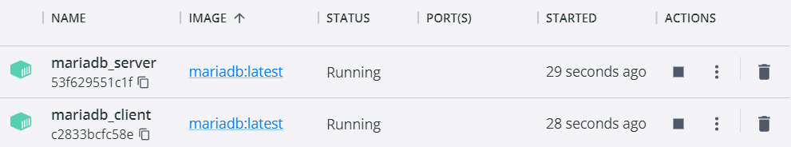
They should be connected in the same network. With the command below you can see all containers in a specified network:
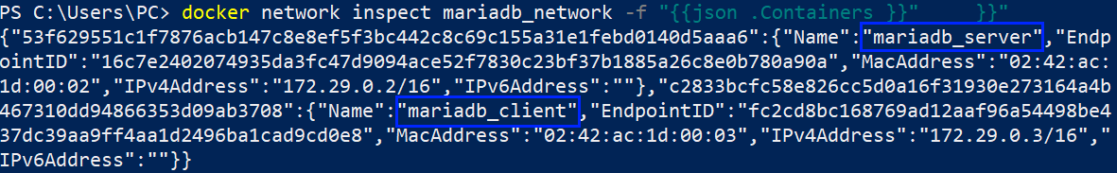
The mariadb_client container should access the mariadb_server container:
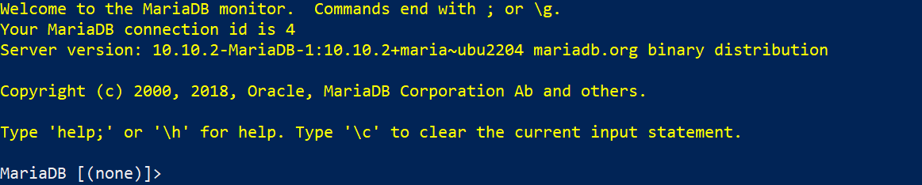
And you should be able to run commands on it:
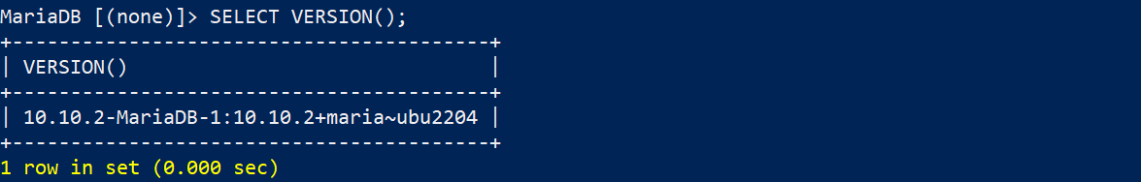
This example shows that we can connect many containers. It is usually necessary to do so and we will see how in the next lesson.

TaskBoard App: Building a Custom Image
In this task and in the other two tasks connected to the TaskBoard app, we will work on the following ASP.NET 6 MVC app with a SQL Server database, provided in the resources:
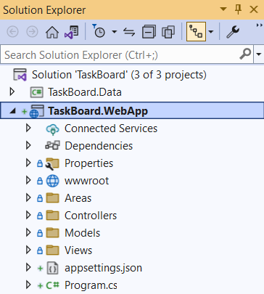
Our task is to create a custom image for this app. Later, we will also publish this image in Docker Hub.

Step 1: Create a Dockerfile in Visual Studio
Our first job is to create a Dockerfile for the app, which will allow us to run it in a Docker container and later connect it to a network. Creating a Dockerfile is easy in Visual Studio, as it is done for you – you should only right-click on the "TaskBoard.WebApp" project and select [Add] [Docker Support…]:
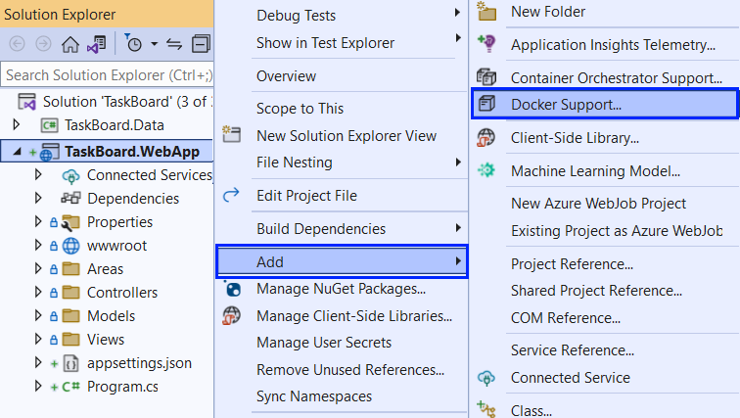
Then, you should choose a target OS for the Dockerfile – choose [Linux], as we are running Linux containers:
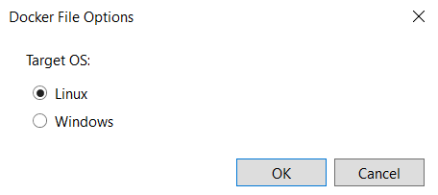
The Dockerfile should be created successfully:
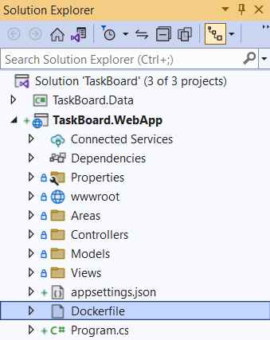
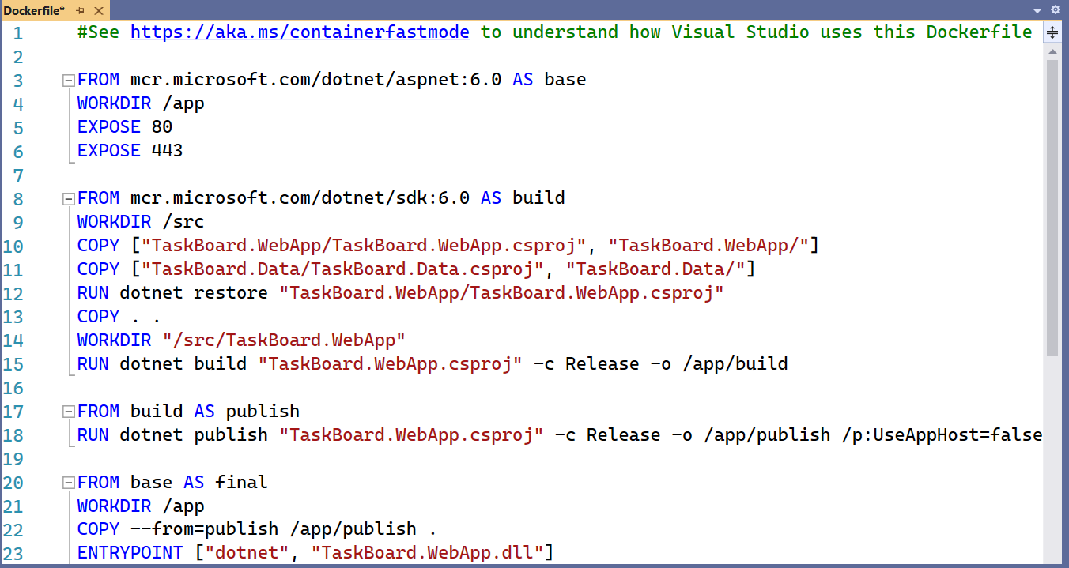
The Dockerfile contains instructions on how an image for the app should be created.

Step 2: Build and Publish the Image to Docker Hub
We can now build a custom image with this Dockerfile. Open a CLI, for example Powershell, and fulfill the following steps to do it:
- Navigate to the TaskBoard solution directory
- Use the docker build command to build the image
- Set the local directory as the working directory
- With the -f option, set the path to the Dockerfile
- With the -t option, set the name of the image in format {your Docker Hub username}/{app name}, as we will later add our image to Docker Hub
The whole command should look similar to this (use your Docker Hub username instead of "softuni"):
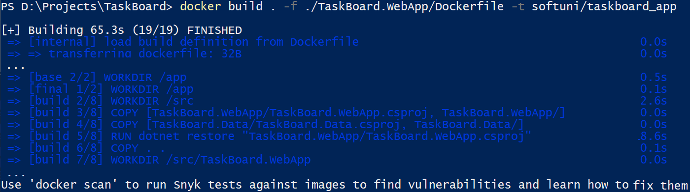
You can see how the instructions from the Dockerfile are followed to build the image. You can see the ready image:
Now let's see how to push our custom image to Docker Hub. Know that this is not needed for running a container with that image – you can have the image only locally and still use it. However, it is good to know how to push images.
To push our image to Docker Hub, we should first log-in to Docker Hub with the command below. If this is the first time you log in, you should enter your credentials. Make sure that login is successful:
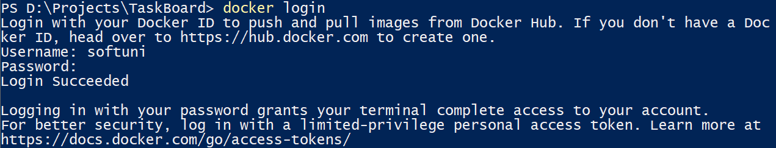
Now you should only push the image:
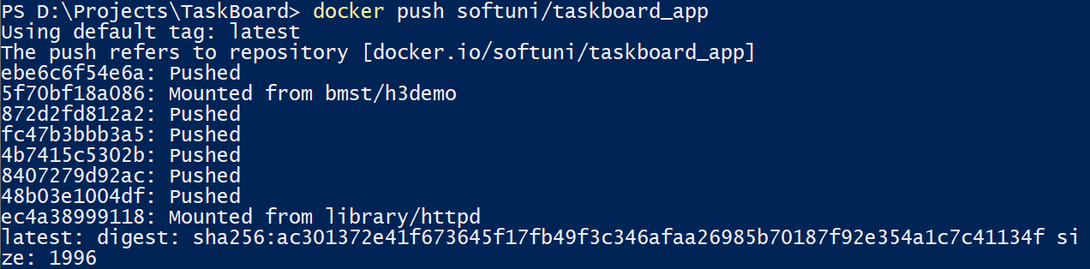

And it is now available at Docker Hub as a public image:
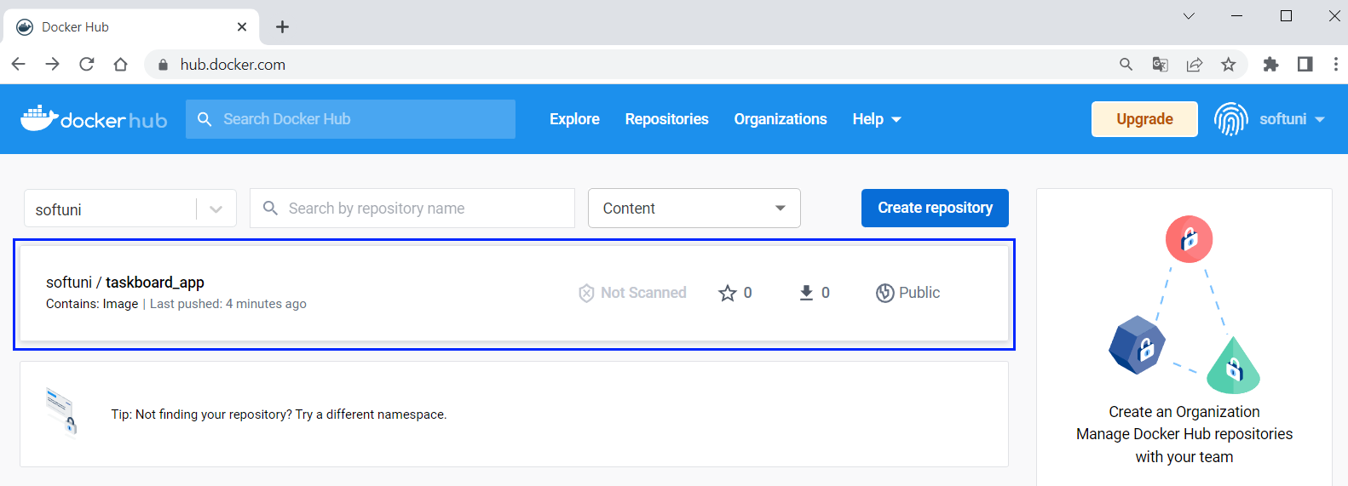
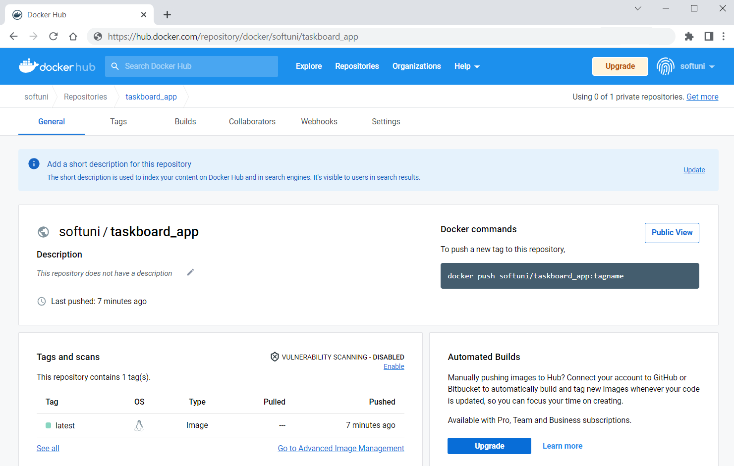
Now keep the image because we will use it in the next TaskBoard app task to run a container. Note that this image is not enough to run you whole app, as it has a database (and it needs a container too).

Tracker App
Your task now is to run a simple JavaScript front-end app based on Vue.js for keeping track of daily duties in a Docker container. It does not need anything but an image to run. It does not use a database or any other types of storage.
You're provided with its files it in the resources, together with a Dockerfile which runs the app on NGINX server:
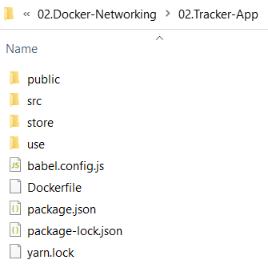
First, build a custom image {username}/tracker_app from the given Dockerfile:
Push the image to Docker Hub:
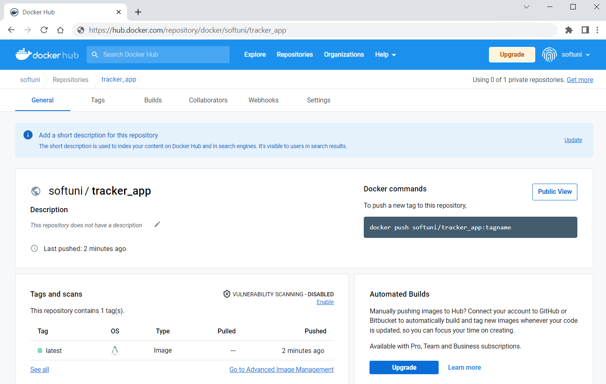
Then, use it to run the Vue app in a container (think about the internal port on which the app works):
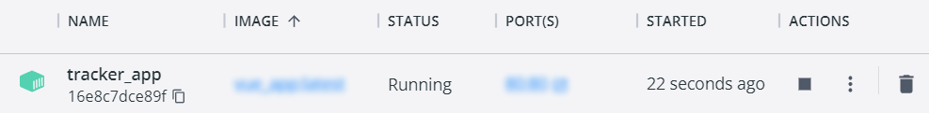
Finally, access the app from the browser – it should be working:
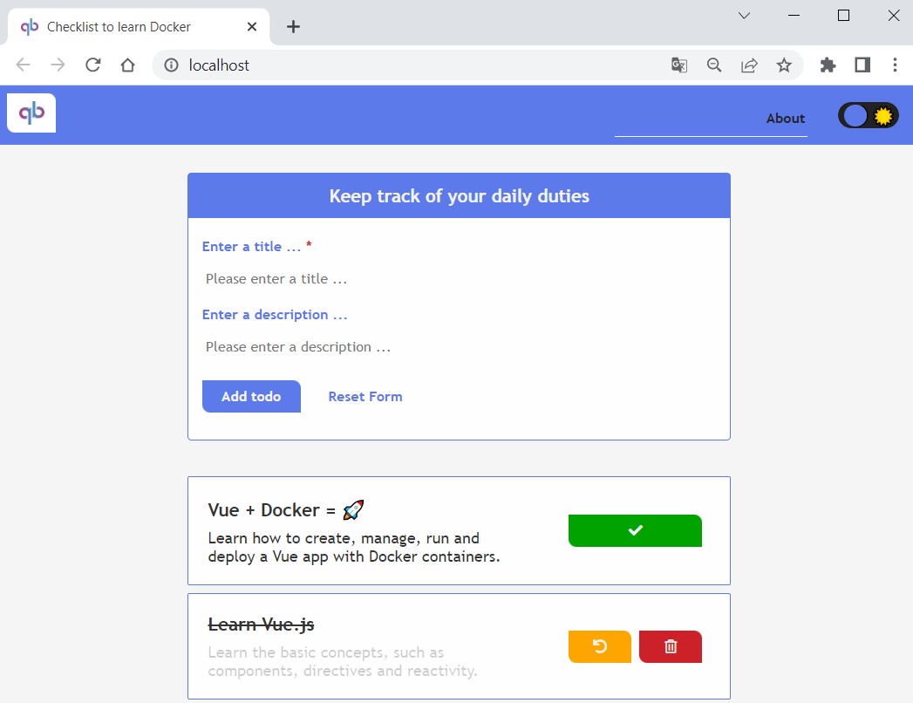

TaskBoard App: Connect Containers in a Network
In this task, we will connect the TaskBoard ASP.NET 6 MVC app to its SQL Server database. They will both be in separate Docker containers, which will be connected to a common network and this will allow them to communicate with each other.
After we have an image for the TaskBoard app and know how to run a SQL Server container, let's learn how to create and connect them to a network.

Step 1: Create a Network
Create a network with name taskboard_network:
You can see all networks with:
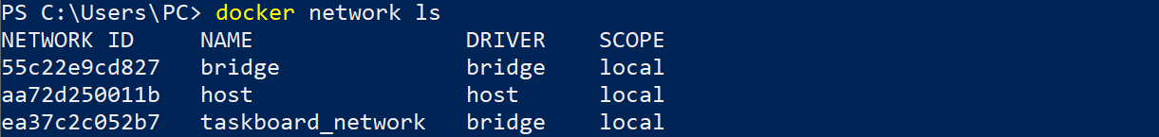

Step 2: Create and Connect a SQL Server Container
Now we want to run a SQL Server container inside our taskboard_network network. You already know how to write the command for creating the Docker container, but we should add some more options to it:
- Use the --network option with the name of the network you want to connect to
- Use the --name option to set a name of the container. This is important as other containers use this name to recognize it in the network
- Use the --rm option to automatically remove the container when it exits (not mandatory)
The command is the following and creates a container in the network:
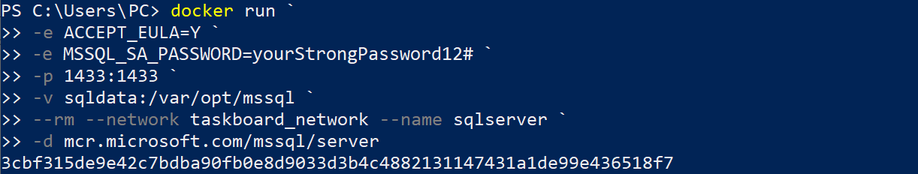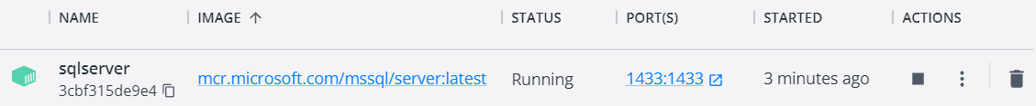
The database container is now working.

Step 3: Create and Connect a TaskBoard App Container
Our next step is to run the TaskBoard app in a container in the same network.
Before that, however, we should change the database connection string of the app, so that it can connect to the SQL Server database we created. Open the appsettings.json file of the "TaskBoard.WebApp" project and modify it according to the following requirements:
- Server should be sqlserver
- Database name is of your choice
- User Id should be sa (the default database system admin user)
- Password should be the admin password we set in the previous command – yourStrongPassword12#
- Allow multiple connections
The connection string should be the following:
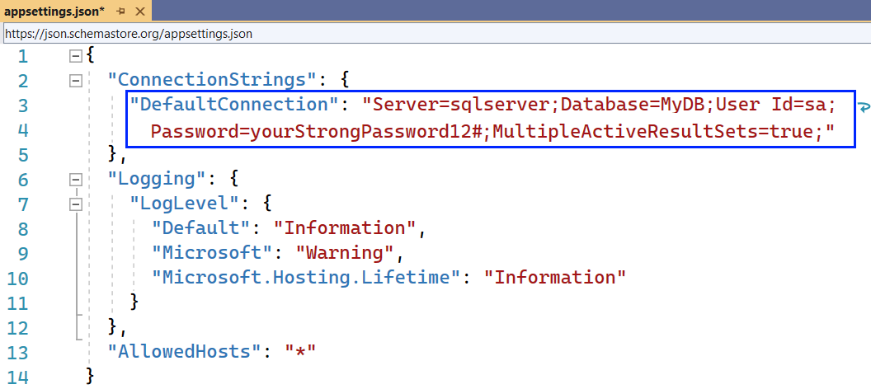
We should build the app image again, so that changes are reflected:
Now you are ready to run the app:
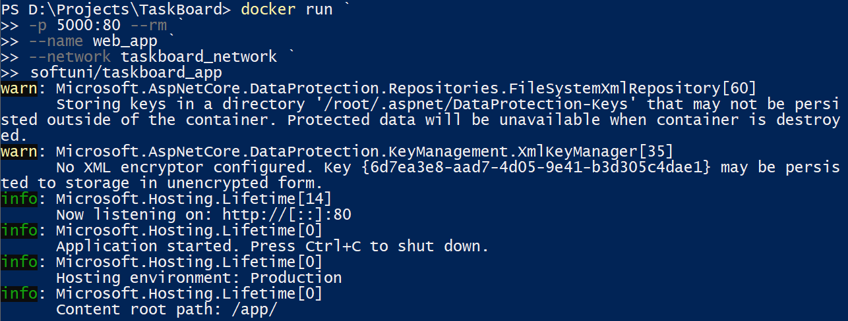
Our Web app is running in a Docker container, too.

Step 4: Containers Together
These are our containers:
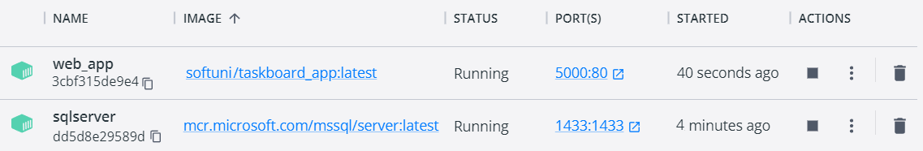
You can also see that they are both connected to out taskboard_network network when inspecting it:
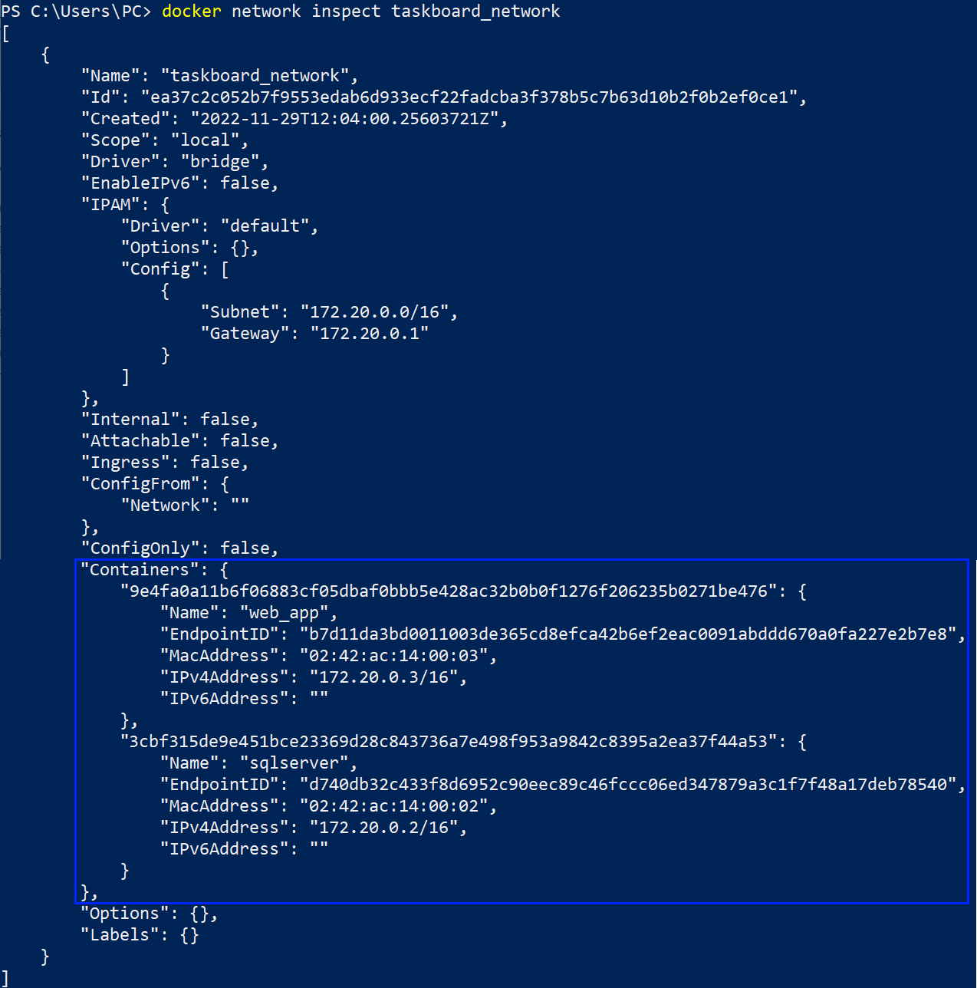

And when you go to http://localhost:5000 you have the fully working TaskBoard Web app with a database:
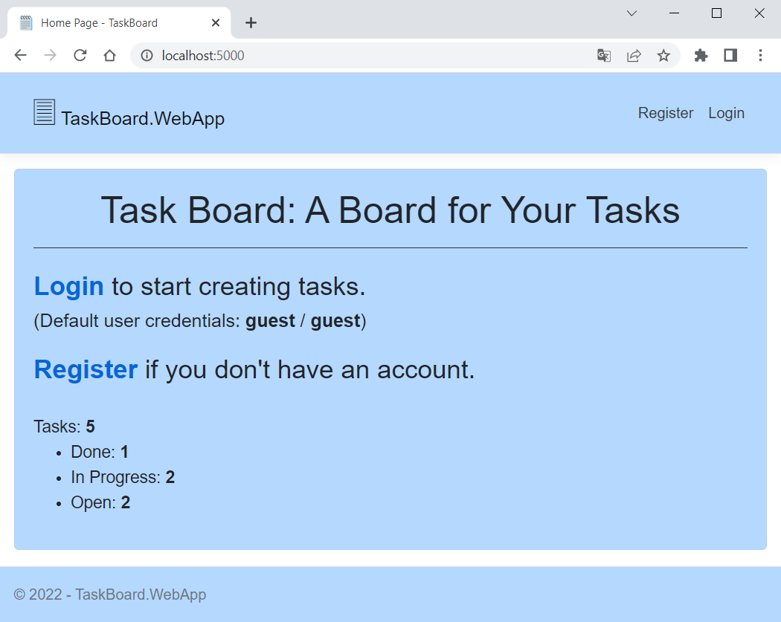
The app should be working – test it by yourself. In addition, you can try to stop the app container and create a new one, connected to the same taskboard_network network and you should see that the database is preserved because it is on a SQL Server container.
That is how you can connect containers in a common network and use them together to run multi-container apps.

TODO App
The TODO app (provided in the resources) is a simple app for adding tasks, which you should Dockerize:
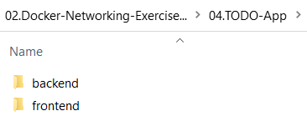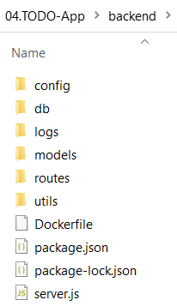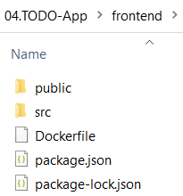
It is a React application with a NodeJS backend and a MongoDB database. You should create the separate Docker containers and connect them in two networks as shown below to make the three containers work together:
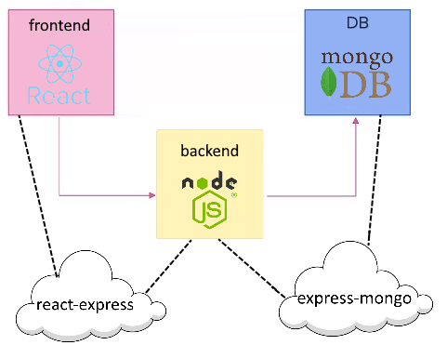

Requirements
- Name the three containers "frontend", "backend" and "mongo"
- Build images from the provided Dockerfiles for the frontend and backend services
- Use the latest image for MongoDB from Docker Hub
- Expose the frontend service on port 3000 (see on which port the app works by yourself)
- Mount the following host directories as volumes:
  - For mongo service: ./data:/data/db
- Connect the frontend and backend services to the react-express network and the backend and mongo services to the express-mongo network
These are the containers that should appear:
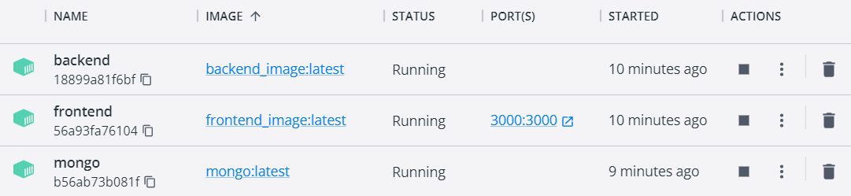
When ready, you should be able to add tasks to the TODO list in the app:
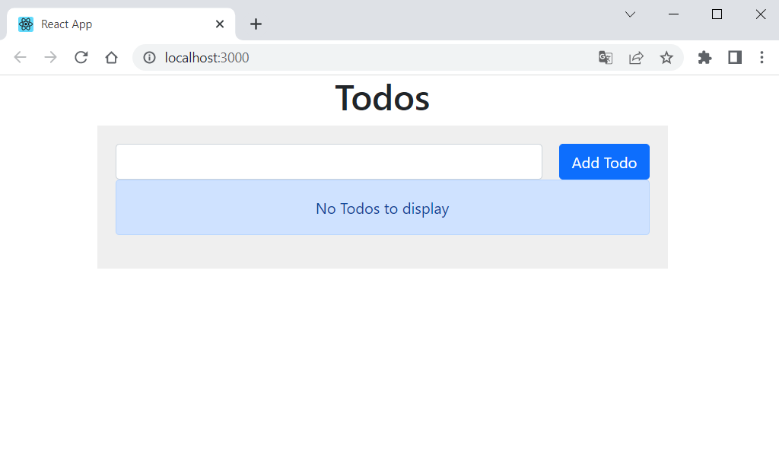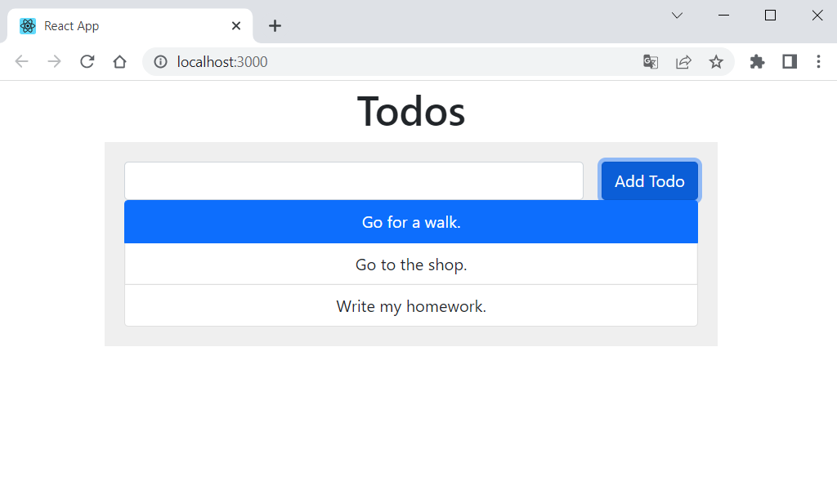

Hints
- Use the docker build command to build the frontend and backend services images in their corresponding folders.
- Create the two networks.
- Run the containers following the requirements and using the images you created and the mongo:latest image.
- To mount a host directory as volume, do it with "-v {host directory path}:{container directory}".
- As you may have seen, you cannot run a container in two networks with the docker run command. For this reason, you should add the container to a network after the container creation with the docker network connect command.

TaskBoard App: Orchestrating Containers with Docker Compose
In this task, we will make our TaskBoard app and SQL Server database containers work together with Docker Compose.

Step 1: Build a YAML File
Our first job is to build a Docker Compose YAML file. It will replace the separate docker run commands for the two containers and combine them into a single file.
Go to your "TaskBoard" solution directory and add a new text file docker-compose with an .yaml extension:
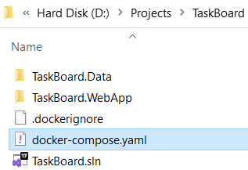
Open the file with any editor and let's write it. Start with the file version – choose the latest one:
Next, we will describe the steps for each service (container). Start with the database service: set the container name, image, ports, environment variables, volume and a custom network – it is all from the docker run command we ran for the container, but in a different format. It should look like this:
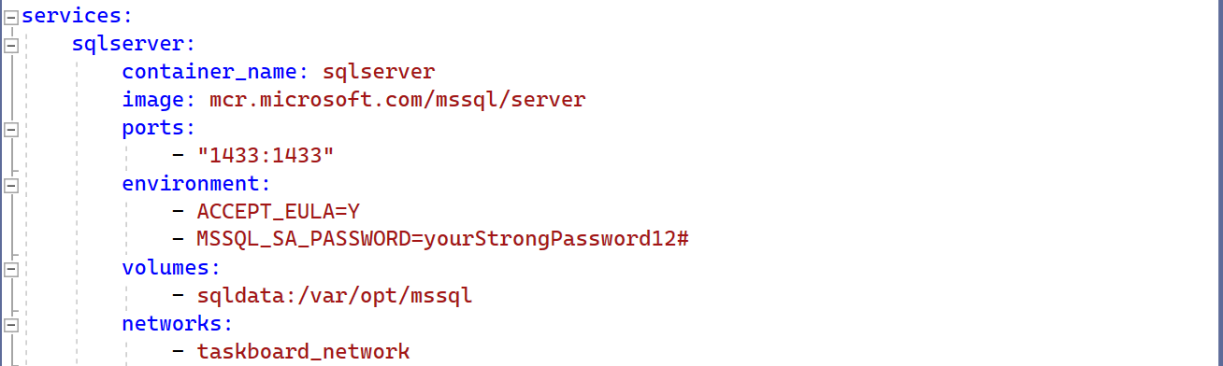
Now write the service for the Web app, which should contain a container name, Dockerfile path, ports, and the same custom network. It may also be set to restart on fail:
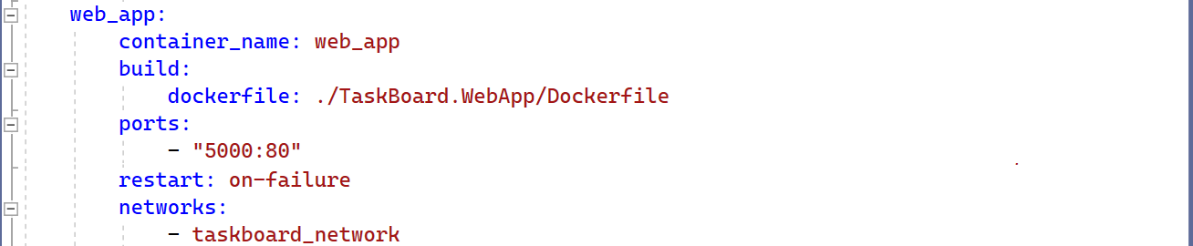
Finally, you should point out the volumes and network you used in the services. You have a single volume and a single network in our case:
Save the file and open a CLI to execute commands on the file.

Step 2: Run the YAML File
First, navigate to the folder of the docker-compose.yaml file and build all images, using the docker compose build command:
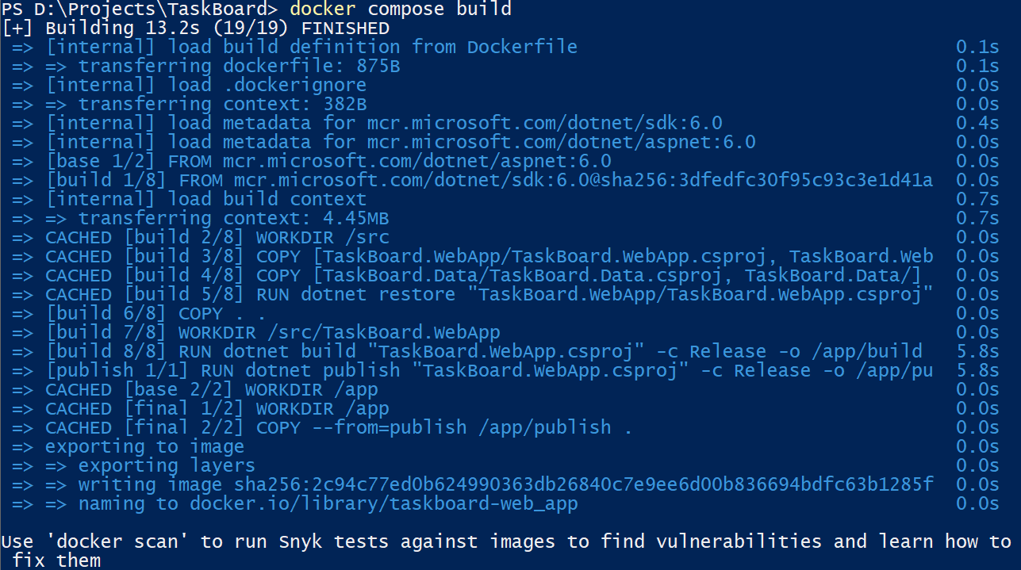

Then, run the containers together with Docker Compose:
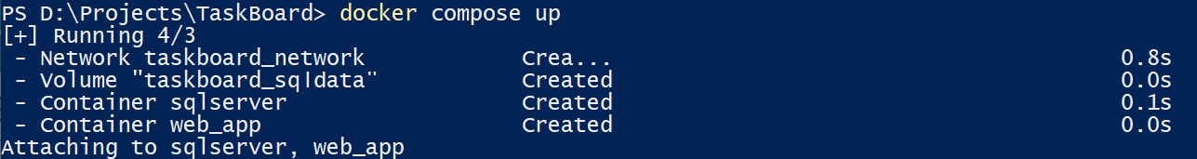
You can see that both database and Web app containers are set and running in our custom network:
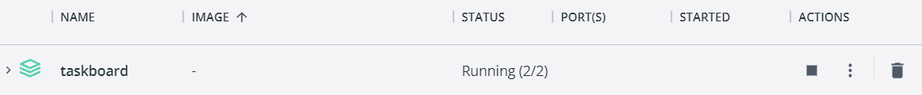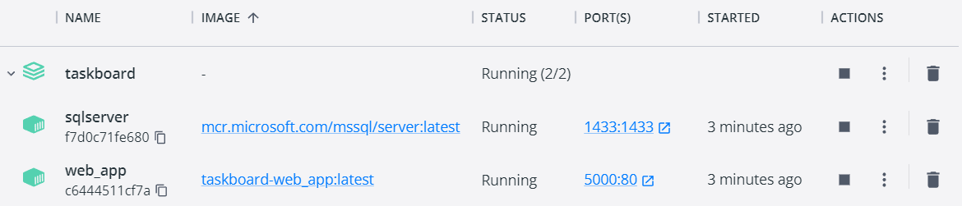
And they are working in the browser, too:

Now you can stop the containers as we will have to run them again after a while.

Step 3: Debug the Web App
Let's see how we are supposed to debug the TaskBoard Web app while it is running inside a container.
To do this, we should first make changes to the Dockerfile – it should have Debug, not Release configurations:
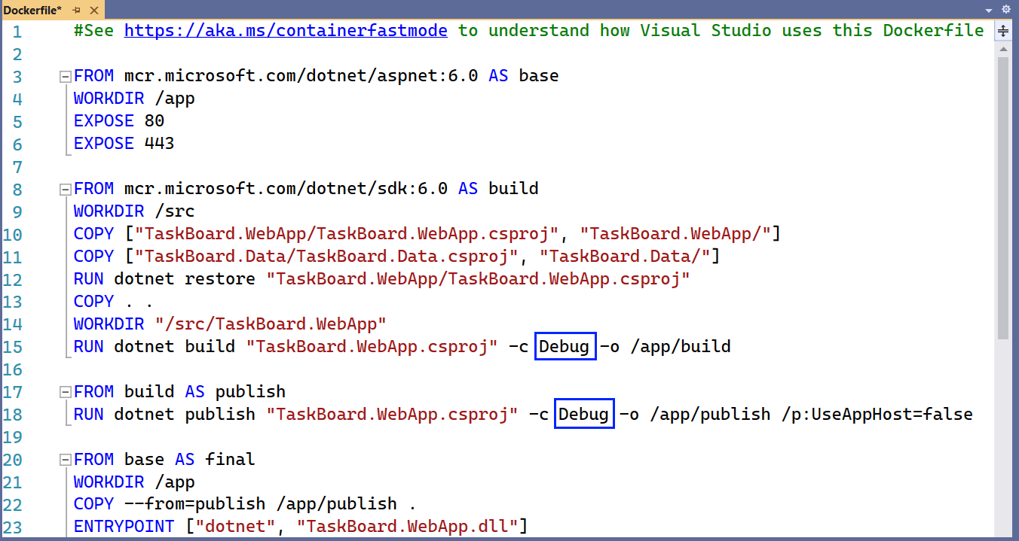
Save the file, build images again with docker compose build and run new containers with docker compose up:
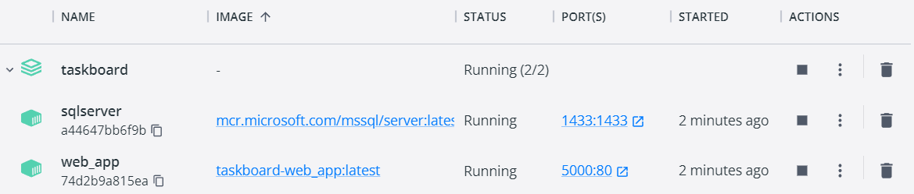
Now, in Visual Studio, go to [Debug] [Attach to Process…] or use the [Ctrl]+[Alt]+[P] keys:
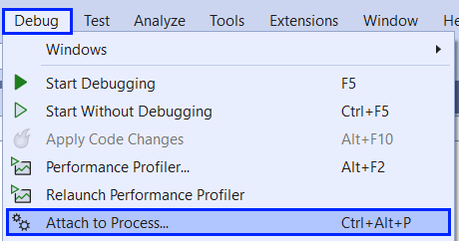
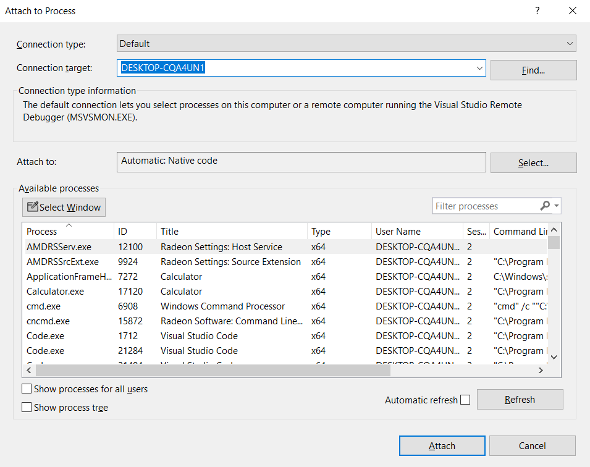
Change the connection type to [Docker (Linux Container)]:
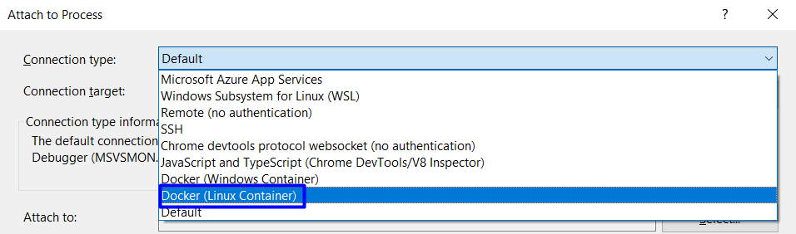
And click on the [Find] button to choose a connection target:
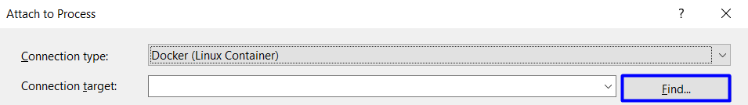
On the next window, select the Web app container and click on [OK]:
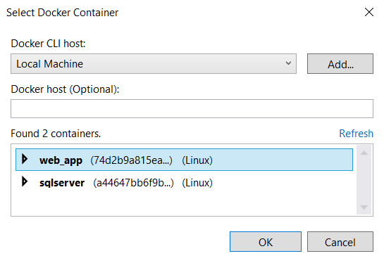
The correct container is chosen, so you should only click on the [Attach] button:
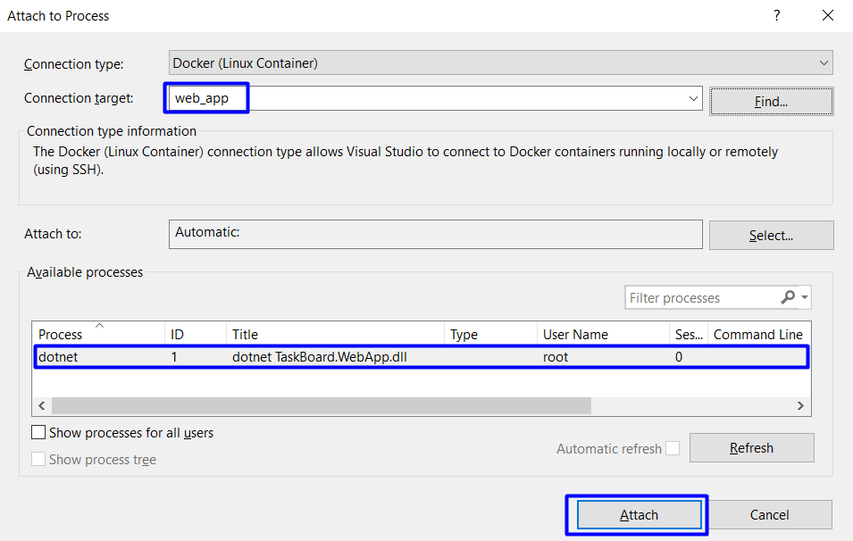
On the final step, choose the [Managed (.NET Core for UNIX)] code type and click [OK]:
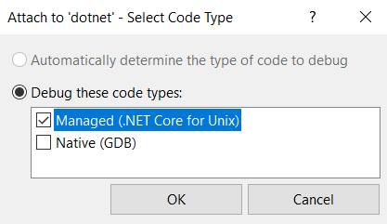
The debug adapter is launched and we are in debug mode:
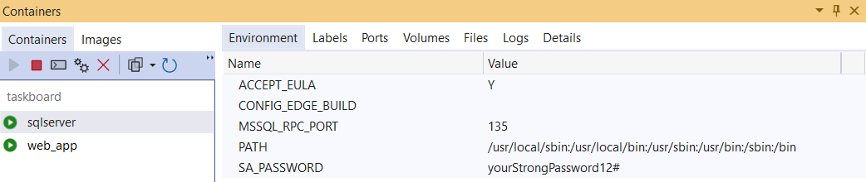
Now you can put a breakpoint, refresh the app in the browser and see if the breakpoint will be reached:
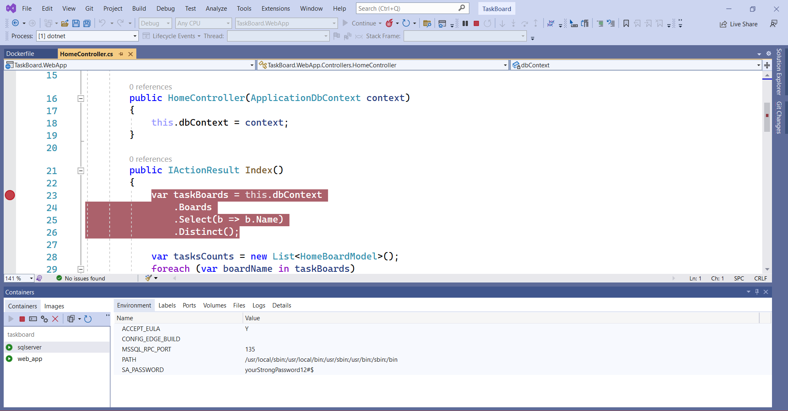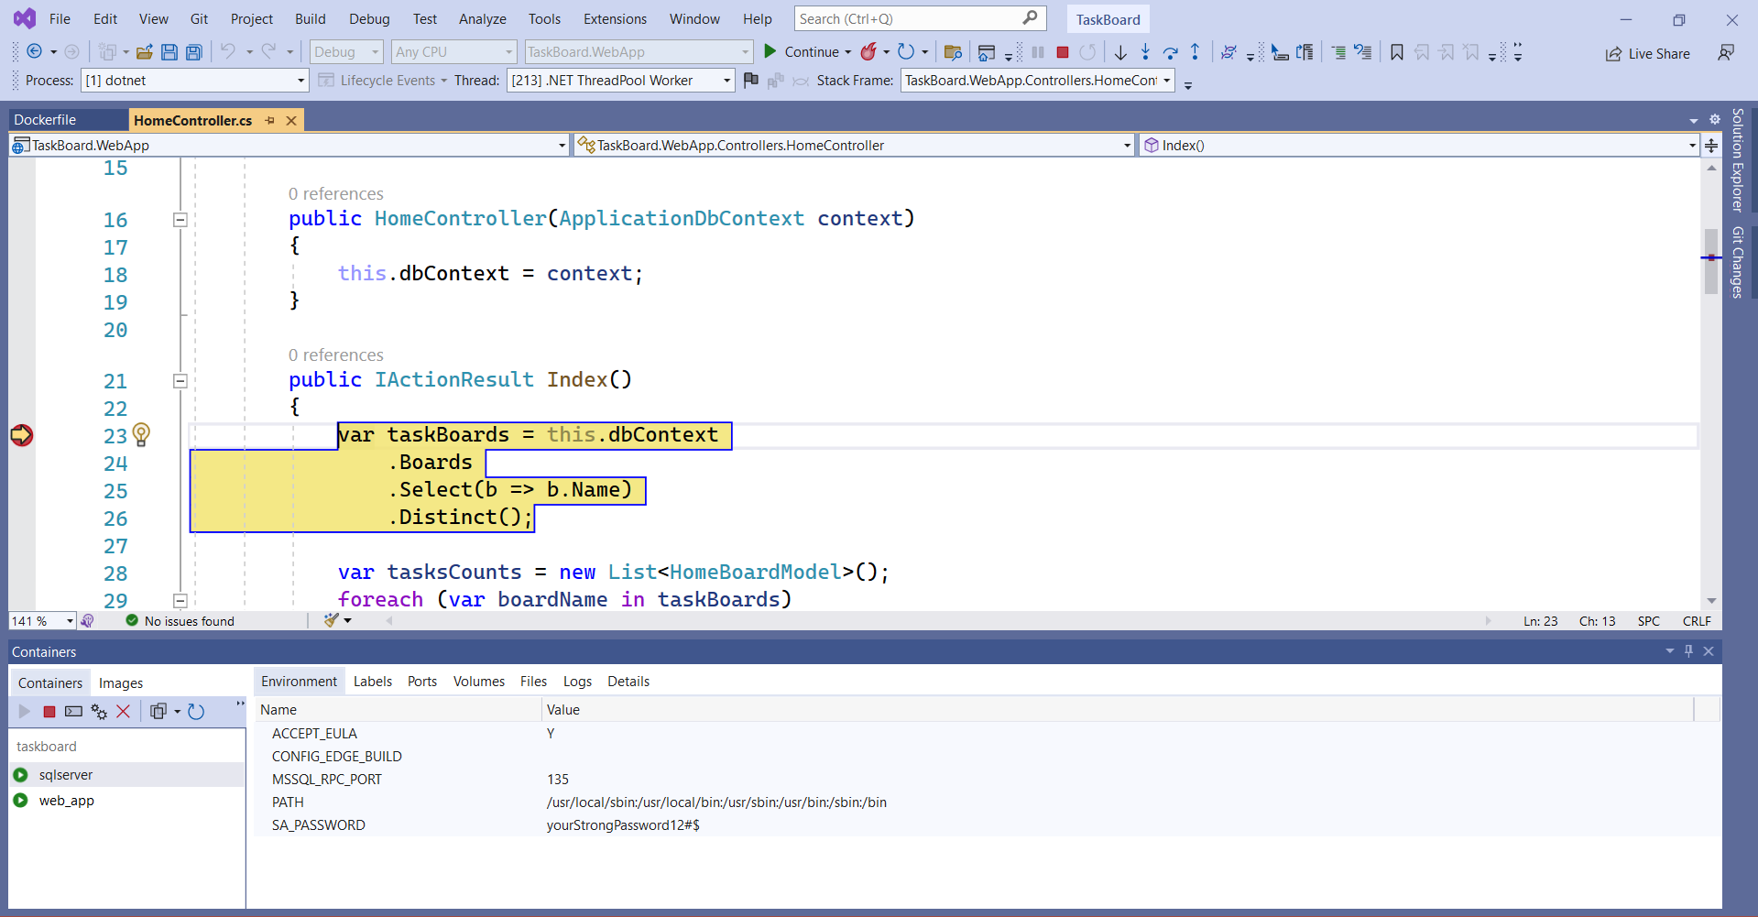
You know how to debug the container app if you need to. Finally, you can use the following command to remove everything together – the containers, images, volumes, etc. (without the network):
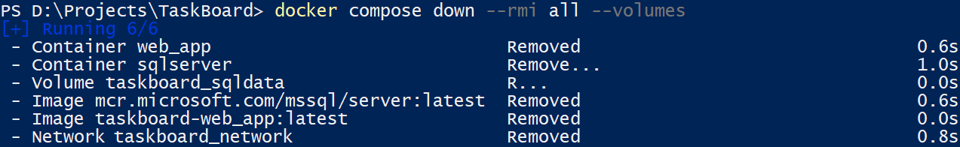
After this task, we now know how to work with custom images, Dockerfiles, networks and Docker Compose. We also know how to run a multi-container ASP.NET Core + SQL Server app.

Blue VS Green App
The "Blue VS Green" app (provided in the resources) is a
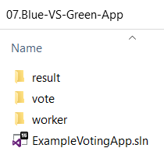
simple voting app, which you should run with Docker Compose:

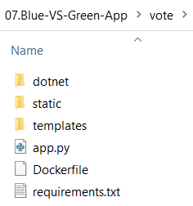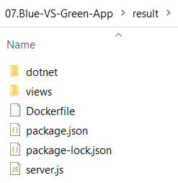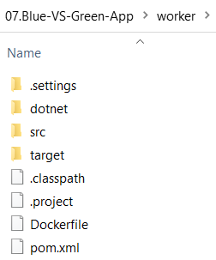
Note that the Dockerfiles for the voting and worker apps you see here are empty.
It provides an interface for a user to vote and another interface to show the results:
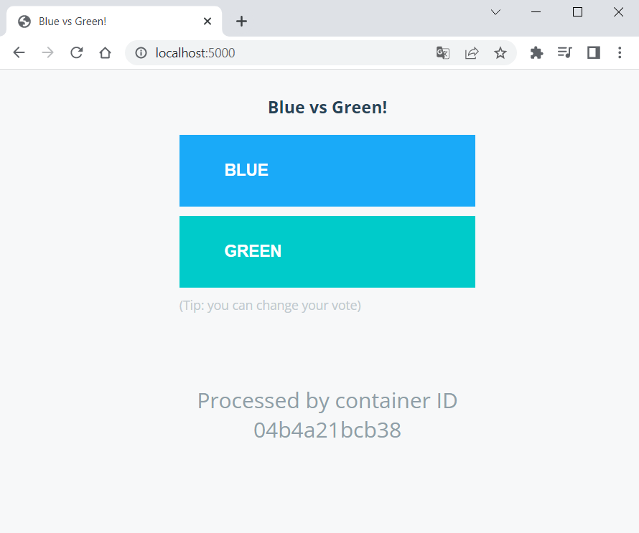
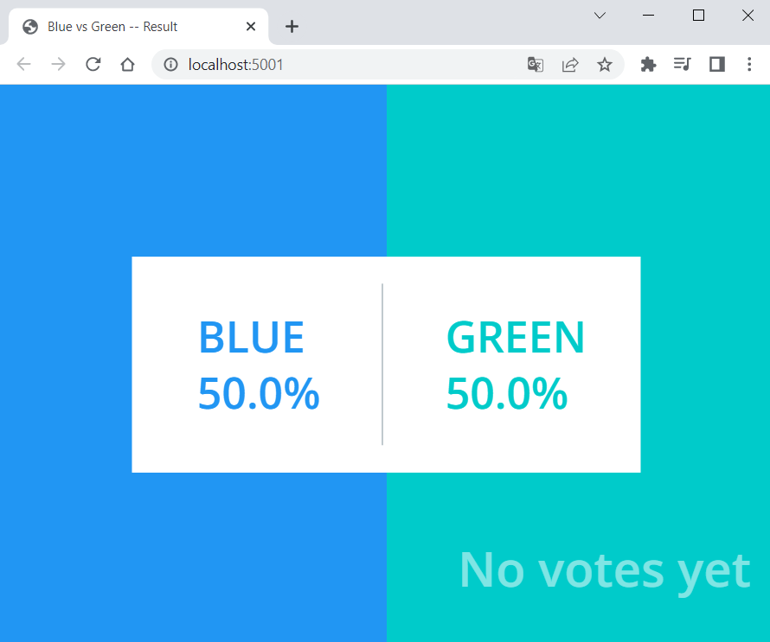
You can vote and then change your vote and this will make changes in the results.
Your task is to fill in the missing instructions in the Dockerfiles and run the app with Docker Compose:
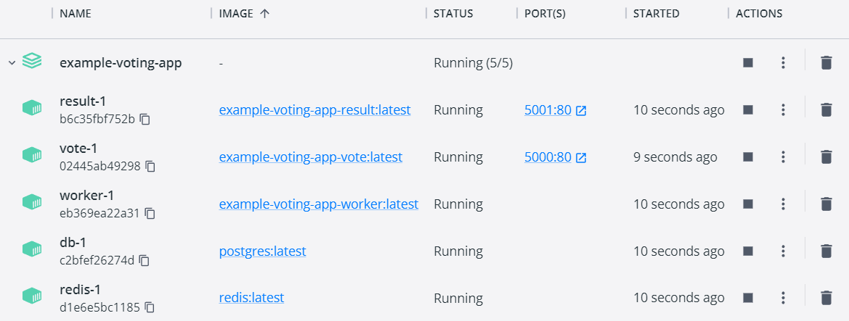
When ready, your app should be working.

Architecture
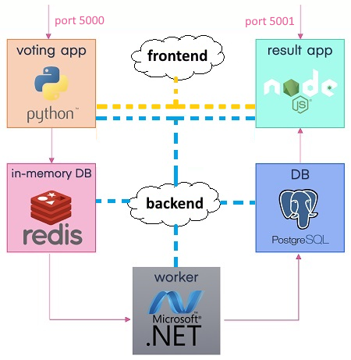
The app has the following architecture:
And consists of:
- A voting app – a Web app, developed in Python, which provides an interface for the user to choose between two options (blue and green)
- An in-memory database on Redis, which stores the user's vote from the voting app
- A worker app on .NET, which processes the new vote by updating the persistent database
- A persistent PostgreSQL database, which has a single table with the number of votes for each category (blue and green)
- A NodeJS Web interface (app), which displays the result of the votes from the PostgreSQL database

Requirements
- Use the latest images for PostgeSQL and Redis from Docker Hub and use the filled-in Dockerfiles for the voting, result and worker app
- PostgreSQL container needs user and password for login: see how to set them in the image's documentation
- The voting app should be accessed on localhost:5000 and the result app – on localhost:5001
- Network traffic should be separated to two networks – frontend and backend:
  - The frontend network is for the users' traffic. Connect the voting app and the result app to it
  - The backend network is for the traffic within the app. It connects all app components
- Run the voting and result apps in the containers
- Use volumes for the voting and result apps and the db container

Hints
Find out how to write the Dockerfiles you need from the Docker Documentation: https://docs.docker.com.
For the voting app, write a Dockerfile for building a Python image:
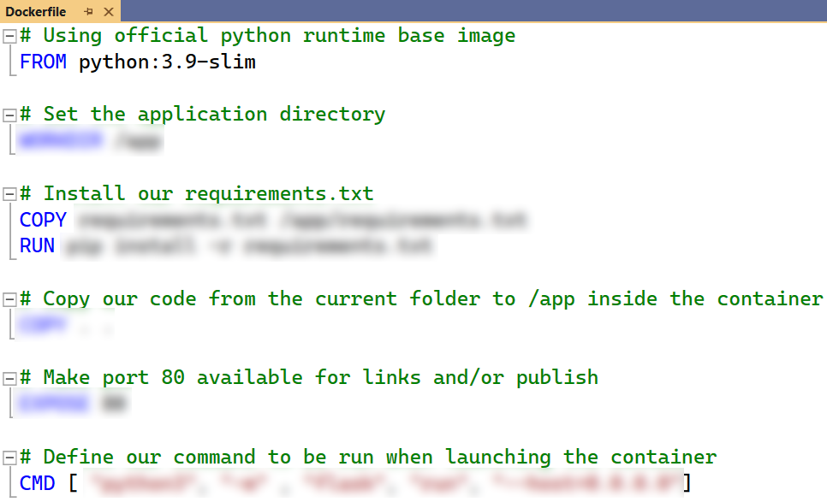
For the worker app, you should build a .NET image:
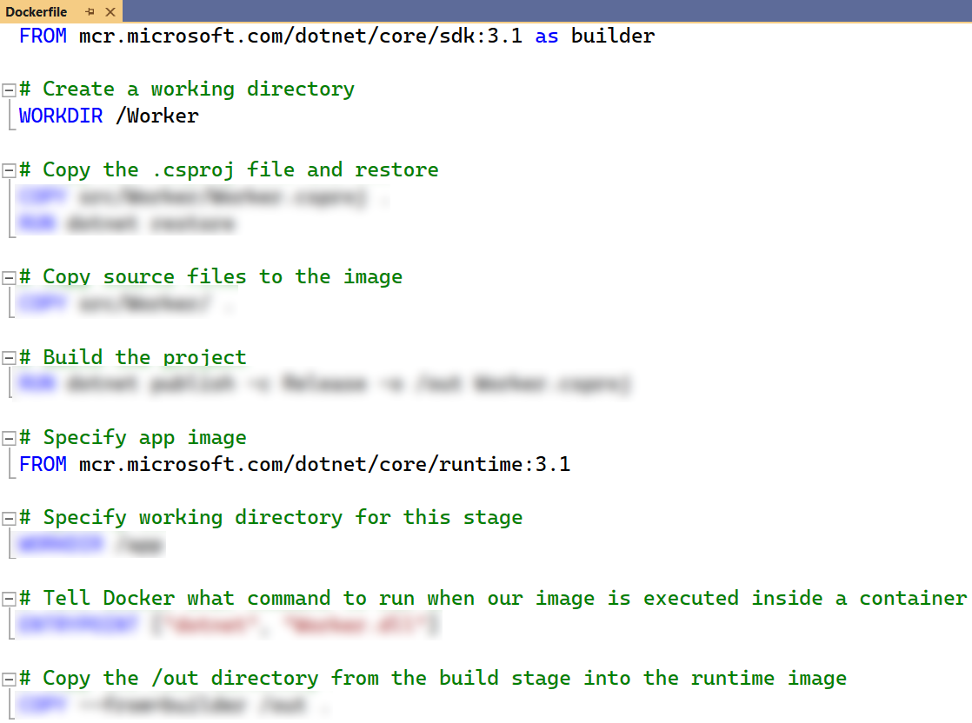
Finally, write the docker-compose.yaml file. This is a sample of how it may look like:
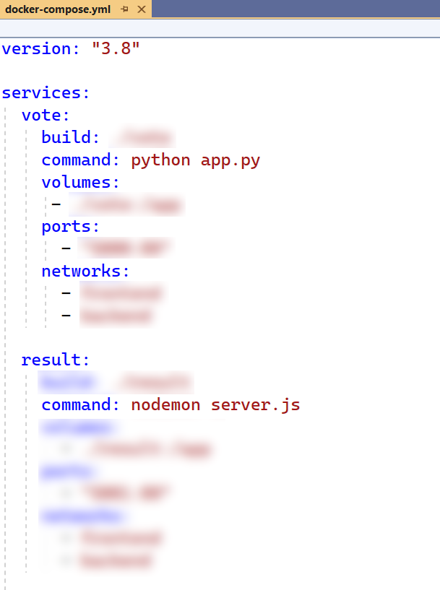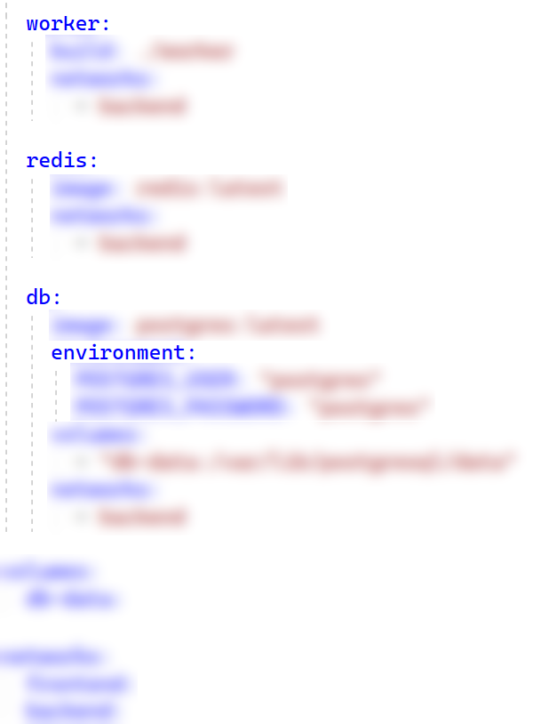
Finally, run the app and see if it works and voting is possible and reflected in results as expected.

Reseller App
In this task, we will work on a Spring Boot app with a MySQL Server database, provided in the resources. Our task is to create a custom image for this app. We will also publish this image in Docker Hub. After that, we will connect the Reseller app to its MySQL Server database. They will both be in separate Docker containers, which will be connected to a common network and this will allow them to communicate with each other. Finally, we will make our Reseller app and MySQL Server database containers work together with Docker Compose.

Step 0: Create a JAR file
A JAR file (Java ARchive) is a package file format used to aggregate many Java class files and associated metadata and resources (such as text, images, etc.) into one file for distribution. It's used for storing compiled Java classes and associated resources, similar to how ZIP files work. JAR files are built on the ZIP file format and have the .jar file extension.
JAR files allow developers to package an application, library, or a set of related classes into a single file, making it easier to distribute and deploy. One of the features of Spring Boot is its ability to produce standalone Spring applications that can be run from the command line without needing an external server. These "fat" JARs include embedded servers and all the necessary dependencies. This makes deploying and running Spring Boot applications very convenient.
When you containerize a Spring Boot application using Docker, the JAR file is often the artifact you'll copy into the Docker container and run. This makes the Dockerfile simpler, as it can focus on setting up the environment and then running the application, rather than compiling code or managing the individual class files.
Now, let's create the JAR file for our Reseller app. If you already have a JAR file for the application, you can skip this step. However, if you don't have the JAR file, you should fulfill the following steps (the JAR file is not provided for our Reseller app, so you should execute the steps):

Install Maven
Download Maven from the official website:
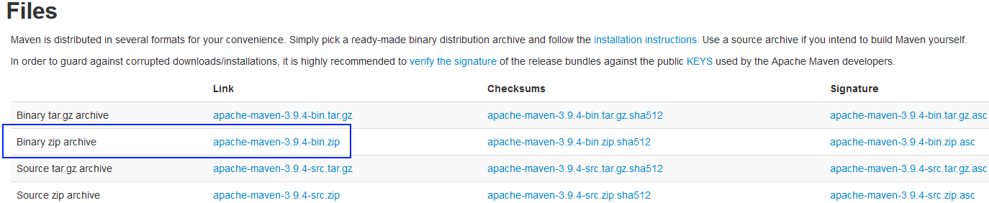
Extract the archive to a directory of your choice and then add the bin directory of the created directory (e.g., apache-maven-3.x.x/bin) to the PATH environment variable.

Setting up the PATH Variable
To add Maven to the PATH variable:
- Right-click on "This PC" or "Computer" on the desktop and choose "Properties".
- Click on "Advanced system settings".
- Click on the [Environment Variables] button.
- Under "System Variables", find the PATH or Path variable, select it, and click on [Edit].
- In the edit window, add the path to the Maven bin directory to the end of the value field. Make sure it's separated from previous paths with a semicolon (;).
- Click [OK], and [OK] again to close the environment variable windows.
You can check if the installation was successful by executing the following command in a CMD:
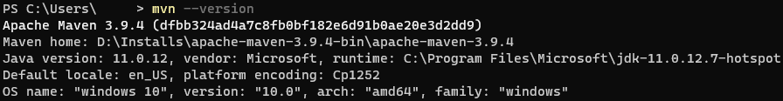

Compile the Project into a JAR File
In order to compile the project into a JAR file, you should execute the following command:
NOTE: If you receive an error that says that there are test failures, add -DskipTests at the end of the command.

Step 1: Create a Dockerfile
Now that we have the JAR file with the compiled project, it's time to create the Dockerfile.
First, we need to specify the base image that will be used to create the new Docker image. In our case, the official OpenJDK image with Java 11 and the JRE (Java Runtime Environment) will be used. We will use the "slim" variant, which is a smaller version of the image that includes only the minimal packages needed to run Java, making the final Docker image size smaller:
Then, we will set metadata for the Docker image. We will specify who the maintainer (or creator) of the image is. The LABEL instruction is used for adding metadata to an image, and it doesn't affect the image's structure or behavior
After that, we will define a variable that users can pass at build-time to the builder with the docker build command. In this case, the variable JAR_FILE will be set to a default value of target/*.jar, which would typically match the compiled JAR file of a Maven project.
Then, we will copy files or directories from the source (in this case, the location specified by ${JAR_FILE}) to the destination in the Docker image's filesystem. In our case, we'll be copying the JAR file matched by the pattern target/*.jar from the host machine to the image and naming it app.jar inside the image:
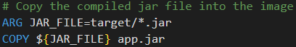
We will expose the part that the app runs on:
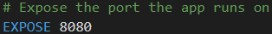
Finally, we will configure a container that will run as an executable – we will start the Java application when the container starts by running the JAR file that we previously copied into the image:
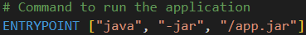

Step 2: Build the Image
Now that we are ready with our Dockerfile we can build the image using this command:

Step 3: Create a Docker-Compose File
Now let's create a docker-compose file so that we can run our app. The Reseller app needs a MySQL server in order to run properly. We will create services for both our app and the MySQL database in the same network. The services will be in separate containers but within the same network. This way, the Spring app will communicate with the MySQL container.
Make sure that the docker-compose file is placed in the root directory of the project, alongside with the pom.xml file.
The configuration should be described following the notes below:

MySQL Service
- image: Use the MySQL image version 8.0
- MYSQL_ROOT_PASSWORD: Create a password for the MySQL root user
- MYSQL_DATABASE: Create a database named resellerdb
- ports: Expose MySQL on port 3306, so you can connect to it from outside if needed
- volumes: Ensure data persistence across container restarts

Reseller App Service
- depends_on: Ensure that the MySQL container starts first
- SPRING_DATASOURCE_URL: The hostname part of this URL (mysql) should match the service name of the MySQL service. The database name is resellerdb (the same as defined in the MySQL service).

Networks
- Both services should be defined to use the same network (backend), so they can communicate with each other.

Volumes
- Volumes: Define a volume for MySQL, ensuring that the database data will persist even if the MySQL container is removed.
The docker-compose.yaml file should look like this:
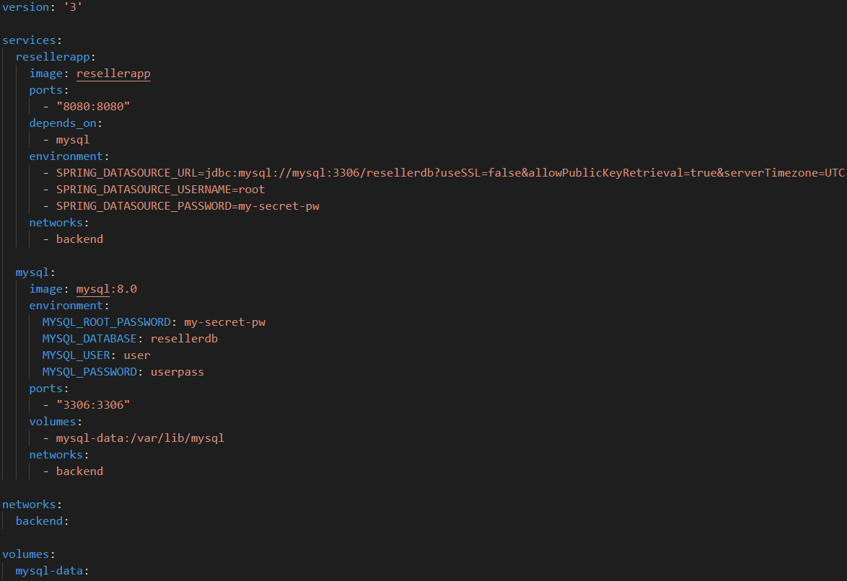

Step 4: Run the Docker-Compose File
After we have our docker-compose file configured, we can run it with the following command:
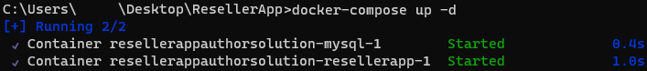
You can add -d at the end of the command in order to run it in detached mode.
Now, when you try to access the Reseller app on http://localhost:8000, you should see the Home page of the application.
If you want, you can register and try the app functionality, so that you can be sure that everything is working as expected.
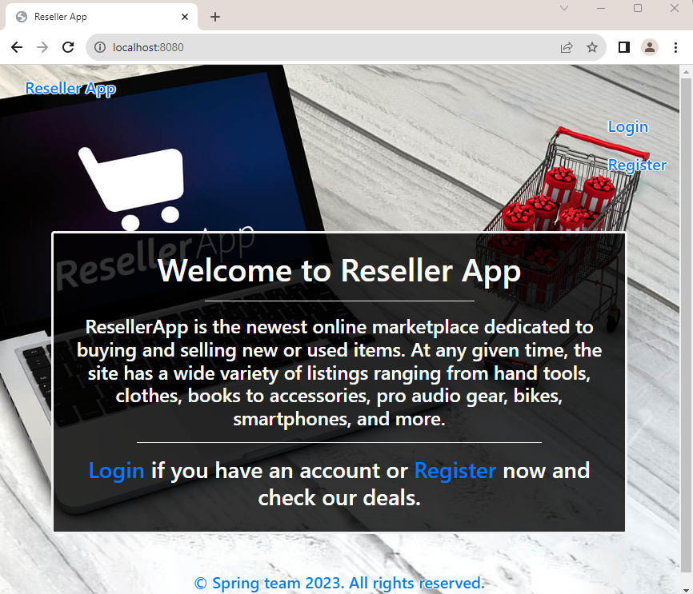

Fruitipedia App
In this task, we will work on a simple Django web app without any databases, provided in the resources. Our task is to create a custom image for this app, create a docker-compose file and run it.
NOTE: Usually, a Django app comes with a requirements.txt file that lists all of the Python dependencies needed to run the app properly. Make sure that you are always provided with the requirements.txt file.

Step 1: Create a Dockerfile
First, let's create the Dockerfile in the root directory of our project, where manage.py is located.
The Dockerfile should follow the requirements below:
Specify the base image to use for the container. Use the official Python image based on Debian Buster with Python 3.8 installed. The slim-buster variant is a minimal version, which makes the image smaller in size.
Set the working directory in the container to /app.
Set environment variables:
- PYTHONDONTWRITEBYTECODE: Prevent Python from writing .pyc files
- PYTHONUNBUFFERED: Ensure that Python output is sent straight to terminal without being buffered, which is useful for logging
Copies the requirements.txt file from your host machine to the /app/ directory in the container.
Install the Python packages specified in requirements.txt and disable the cache to make the image smaller.
Copy all files and folders from your current directory on your host machine into the /app/ directory in the container.
Creates a new directory named staticfiles in the /app/ directory of the container.
Copies the static folder from your host machine into /app/staticfiles in the container.
Expose port 8000.
Finally, specify the command to run when the container starts. In our case, it should start the Gunicorn HTTP server and runs our application on port 8000.
Here's how it should look:
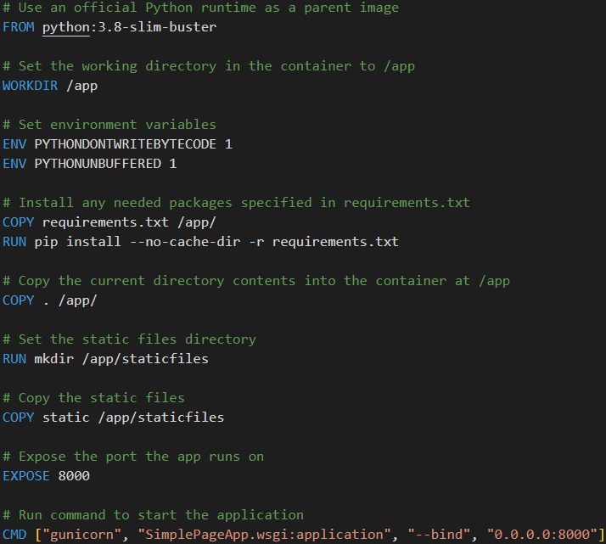

Step 2: Create a Docker-Compose File
Now let's create a docker-compose file so that we can run our app.
Make sure that the docker-compose file is placed in the root directory of the project.
The configuration should be described following the notes below:

Compose Version
Specify the Docker Compose file format version to use version 3.8.

Services
Web Service:
- web: Define a new service named web
- build: .: Build the Docker image for this service using the Dockerfile in the current directory
- volumes: Define volume mounts for this service
- ./static:/app/staticfiles: Map the current directory on the host to /app inside the container
- ports: Publish port 8000 of the service to port 8000 on the host machine
- DEBUG=False
Finally, the file should look like this:
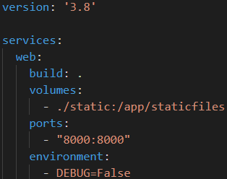

Step 3: Build and Run the Docker Container
After we have the docker-compose.yaml file, we can start the service by running the following command from the root directory, where the docker-compose.yml file is located:
That's it! Your Django application should now be running, and you should be able to access it at http://localhost:8000
